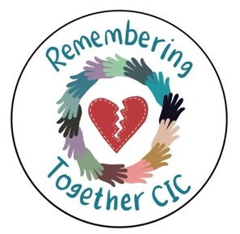

Sources of help and support

Remembering Together CIC does not offer counselling or crisis services. However, we do offer supported signposting to sources of support. Peer connection is available via our Facebook group (Remembering Together). At our workshops and events, we will listen without judging or intruding and assist people to access the support they need.
Please email RememberingTogetherGroup@gmail.com for details.

For support with a bereavement:
At A Loss - Bereavement support signposting service www.ataloss.org has contact details for a wide variety of organisations that can offer support.

The Compassionate Friends - Supporting bereaved parents and their families. 0345 123 2304 helpline or helpline@tcf.org.uk

Cruse - Bereavement support 0808 808 1677 or www.cruse.org.uk

Help is at hand- This free booklet, Help is at Hand: Support After Someone May Have Died by Suicide is available from
https://www.nhs.uk/Livewell/Suicide/Documents/Help%20is%20at%20Hand.pdf

Hope After Suicide Loss – support@hopeaftersuicideloss.org.uk 0753 1087623

Hub of Hope have a search tool to look for different kinds of national and local bereavement support. See: hubofhope.co.uk

Nelson’s Journey support bereaved children and young people in Norfolk see: nelsonsjourney.org.uk

Norfolk and Waveney MIND offer a range of mental health and bereavement services including a complex bereavement service which are detailed on their website: norfolkandwaveneymind.org.uk

For support with feelings of distress or thoughts of suicide:

Papyrus (prevention of young suicide) - For confidential suicide prevention advice contact HOPELINEUK. Open 9am–midnight every day. 0800 068 4141 or pat@papyrus-uk.org

Samaritans- For confidential 24/7 support about any worries the Samarians offer a listening ear via 116 113 (this number does not appear on phone bills).

To access mental health services:
Phone 111, refer to your local mental health’s website for support in your area, or see your GP. In an emergency phone 999 or go to A and E

